# **Name: Abdurrahman Qureshi**

# **Roll No: 210451**

Practical No: 1

**1) WAP to print “Hello World”**

**CODE:**

<html>

<head>

<title>EXP 1 - A</title>

<script>

document.write("<h3>Hello World</h3>");

</script>

<style>

h3{

color: #ccc;

}

</style>

</head>

<body style="background-color: #111">

<footer>

<h3>Abdurrahman Qureshi</h3>

<h3>210451</h3>

</footer>

</body>

</html>

**OUTPUT:**

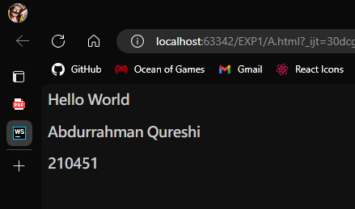

**2) WAP to take user name as input and print it.**

**CODE:**

<html>

<head>

<title>EXP 1 - B</title>

<script>

const name = prompt("Enter your name below:");

document.write("<h3>Username : " + name + "</h3>");

</script>

<style>

h3 {

color: #ccc;

}

</style>

</head>

<body style="background-color: #111">

<footer>

<h3>Abdurrahman Qureshi</h3>

<h3>210451</h3>

</footer>

</body>

</html>

**OUTPUT:**

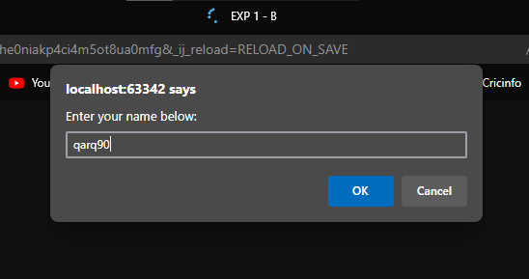 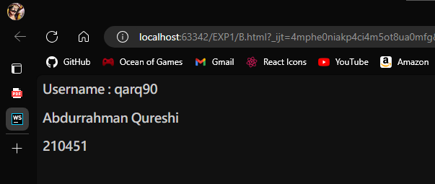

**3) WAP for arithmetic expression evaluation and message printing**

**CODE:**

<html>

<head>

<title>EXP 1 - C</title>

<script>

const name = prompt("Enter your name below:");

document.write("<h3>Username : " + name + "</h3>");

</script>

<style>

h3 {

color: #ccc;

}

</style>

</head>

<body style="background-color: #111">

<footer>

<h3>Abdurrahman Qureshi</h3>

<h3>210451</h3>

</footer>

</body>

</html>

**OUTPUT:**

